15.35: The wave equation is a linear equation, as it is linear in the derivatives, and differentiation is a linear operation. Specifically,

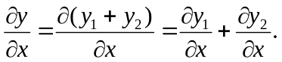

Repeating the differentiation to second order in both x and t,
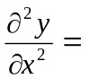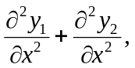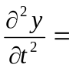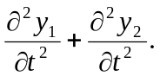

The functions 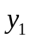and 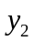are given as being solutions to the wave equation; that is,

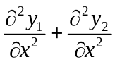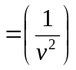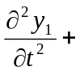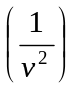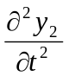

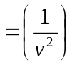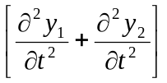

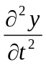

and so 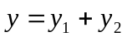 is a solution of Eq. (15.12).

